**Steps to Implement Database:**

We will do it locally first.

Download mysql server!!!! **Not the same as workbench:**

<https://dev.mysql.com/downloads/mysql/>

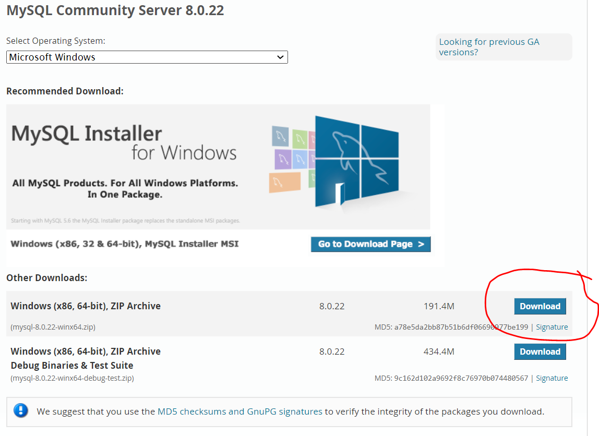

Install the default setting:

-> Mysql sever 8.0

After installation, go to your MySql.

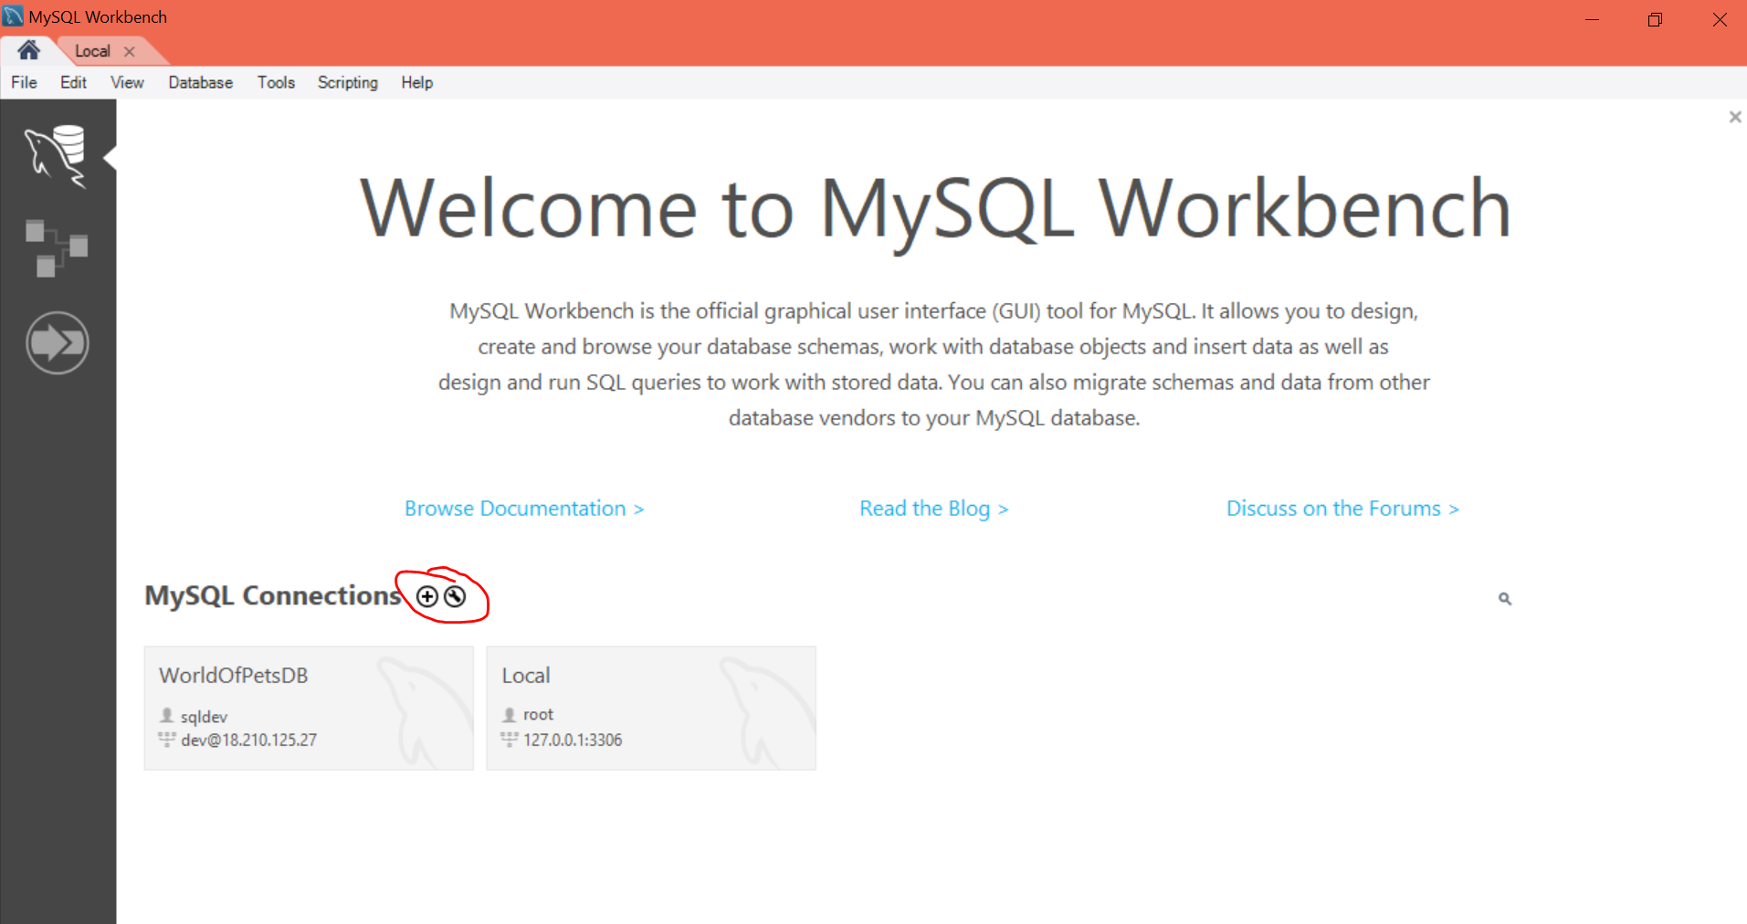

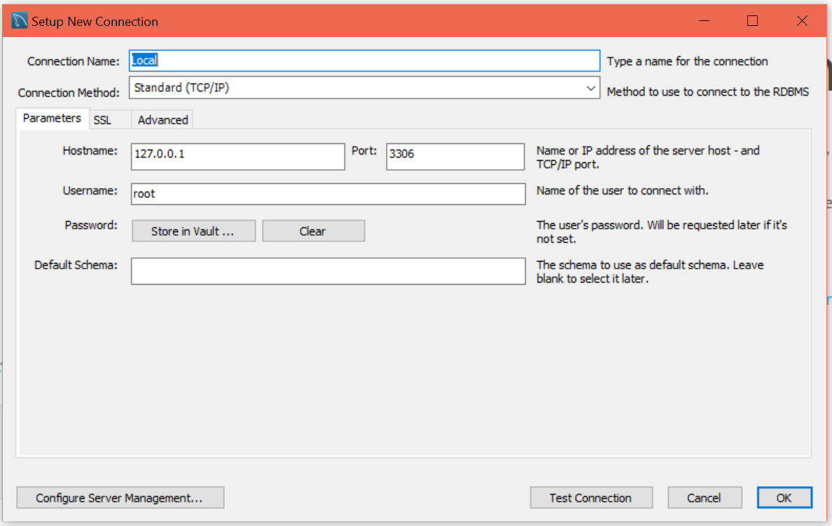

Password is the password you set up in the root server.

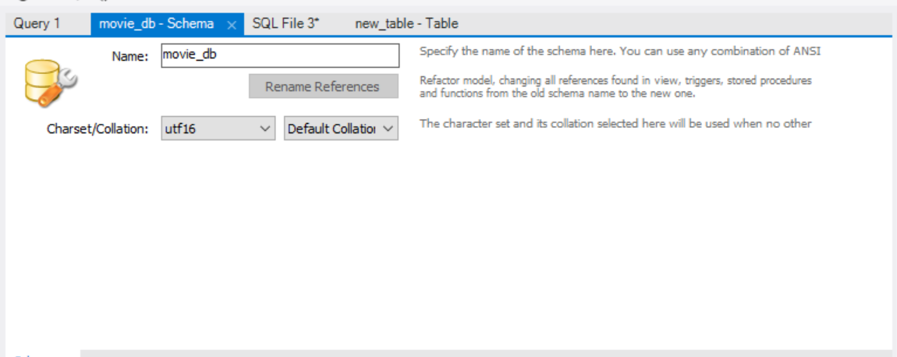

Create schema

**Paste this code in!!**

CREATE TABLE `movie_db`.Customers

(

Cust_ID INT NOT NULL AUTO_INCREMENT,

Name VARCHAR(45) NOT NULL,

Membership_Pts INT,

Email VARCHAR(45) NOT NULL,

Password VARCHAR(255) NOT NULL,

PRIMARY KEY (Cust_ID),

UNIQUE (Email)

);

CREATE TABLE `movie_db`.Movie

(

Movie_Title VARCHAR(50) NOT NULL,

Movie_ID INT NOT NULL AUTO_INCREMENT,

Ratings INT,

Description_ VARCHAR(800),

Release_Date_ DATE NOT NULL,

PRIMARY KEY (Movie_ID)

);

CREATE TABLE `movie_db`.Actor_

(

Actor_Name VARCHAR(50) NOT NULL,

Age INT,

Description VARCHAR(800),

Actor_ID_ INT NOT NULL AUTO_INCREMENT,

PRIMARY KEY (Actor_ID_)

);

CREATE TABLE `movie_db`.Genre

(

Genre_ID INT NOT NULL AUTO_INCREMENT,

Genre_Name VARCHAR(50) NOT NULL,

Description VARCHAR(600) NOT NULL,

PRIMARY KEY (Genre_ID)

);

CREATE TABLE `movie_db`.Cinemas

(

Name VARCHAR(50) NOT NULL,

Descriptions_ VARCHAR(800) NOT NULL,

Cinema_ID INT NOT NULL AUTO_INCREMENT,

Location VARCHAR(100) NOT NULL,

PRIMARY KEY (Cinema_ID),

UNIQUE (Location)

);

CREATE TABLE `movie_db`.Hall

(

Capacity INT NOT NULL,

Hall_ID INT NOT NULL AUTO_INCREMENT,

Type VARCHAR(100) NOT NULL,

Cinema_ID INT NOT NULL,

PRIMARY KEY (Hall_ID),

FOREIGN KEY (Cinema_ID) REFERENCES Cinemas(Cinema_ID)

);

CREATE TABLE `movie_db`.Seat

(

SeatNo INT NOT NULL,

Hall_ID INT NOT NULL,

PRIMARY KEY (SeatNo),

FOREIGN KEY (Hall_ID) REFERENCES Hall(Hall_ID)

);

CREATE TABLE `movie_db`.Acts_In

(

Movie_ID INT NOT NULL,

Actor_ID_ INT NOT NULL,

PRIMARY KEY (Movie_ID, Actor_ID_),

FOREIGN KEY (Movie_ID) REFERENCES Movie(Movie_ID),

FOREIGN KEY (Actor_ID_) REFERENCES Actor_(Actor_ID_)

);

CREATE TABLE `movie_db`.Movie_Genre

(

Movie_ID INT NOT NULL,

Genre_ID INT NOT NULL,

PRIMARY KEY (Movie_ID, Genre_ID),

FOREIGN KEY (Movie_ID) REFERENCES Movie(Movie_ID),

FOREIGN KEY (Genre_ID) REFERENCES Genre(Genre_ID)

);

CREATE TABLE `movie_db`.Rate

(

Comments VARCHAR(800) NOT NULL,

Rating_Number INT NOT NULL,

Date_Time DATETIME NOT NULL,

Cust_ID INT NOT NULL,

Movie_ID INT NOT NULL,

PRIMARY KEY (Date_Time, Cust_ID),

FOREIGN KEY (Cust_ID) REFERENCES Customers(Cust_ID),

FOREIGN KEY (Movie_ID) REFERENCES Movie(Movie_ID),

UNIQUE (Cust_ID, Movie_ID)

);

CREATE TABLE `movie_db`.Movie_Tickets

(

Ticket_ID INT NOT NULL AUTO_INCREMENT,

Time_Slot DATETIME NOT NULL,

Price FLOAT NOT NULL,

Hall_ID INT NOT NULL,

Cust_ID INT NOT NULL,

Movie_ID INT NOT NULL ,

PRIMARY KEY (Ticket_ID),

FOREIGN KEY (Hall_ID) REFERENCES Hall(Hall_ID),

FOREIGN KEY (Cust_ID) REFERENCES Customers(Cust_ID),

FOREIGN KEY (Movie_ID) REFERENCES Movie(Movie_ID)

);